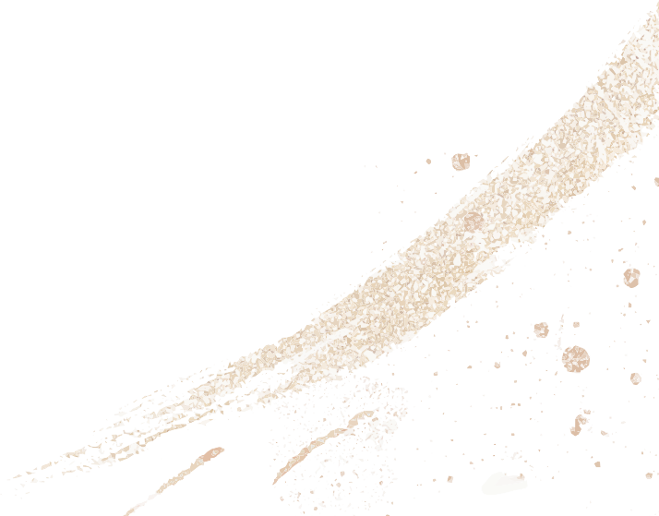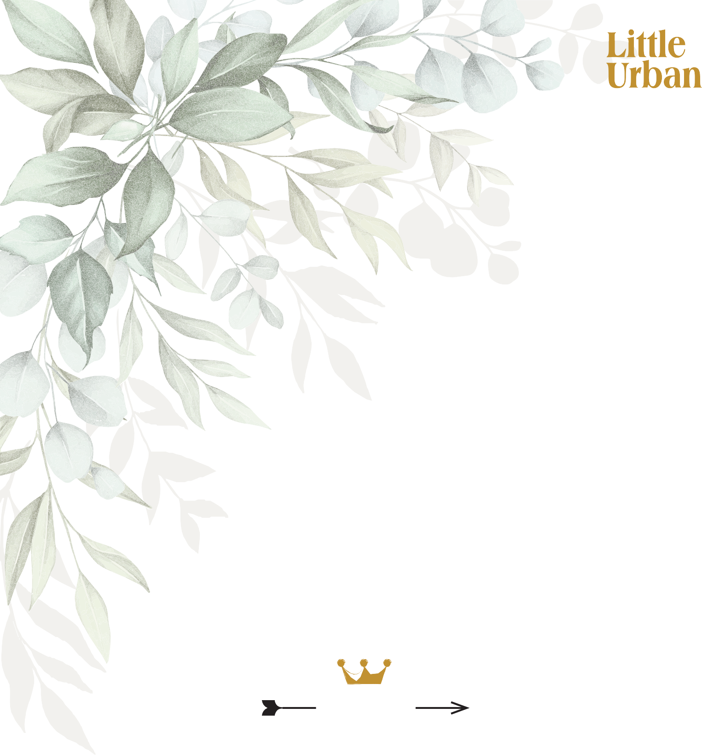M u

HIGH TEA
High tea $42 per person or $50 with a glass of bubbles;
Vegan, vegetarian & Gulten free: $47 per person or $55 with a glass of bubbles; Children under 12 $25 for 5 items with a hot chocolate or juice.

Coronation Chicken Croissant Prawn Rice Paper Roll
Egg & Herb Finger Sandwich Avocado Mousse & Smoked Salmon Vol au vent
Scone, Raspberry Jam & Cream Macaron
Mini Passionfruit & Lemon Tart Orange & Poppyseed Cake with Mascarpone Vanilla Pannacotta with Cherry Compote

1700s
Monday to Friday
11am to 2pm
Join us for High Tea, make a booking at Little Urban.

The British tradition of High Tea began in the mid- 1700s as an afternoon meal usually served between 3 and 4 pm.
Initially, it was a meal for the working class, taken standing up or sitting on tall stools, thus termed ‘high’.
Tea with cakes, scones and even cheese on toast were served.
This afternoon meal was adopted by society’s upper classes as an important event on the social calendar, rather than a meal for the working class.
For the ‘Leisure Classes’, High Tea served a practical purpose, allowing Ladies and Gentleman the opportunity of a substantial meal before attending the theatre or playing cards. Evening supper may not be served until fashionably late in the evening.
It was around this time that John Montagu, the Fourth Earl of Sandwich, came up with the idea of placing meat and other fillings between two slices of bread. This is how the High Tea sandwich was created.

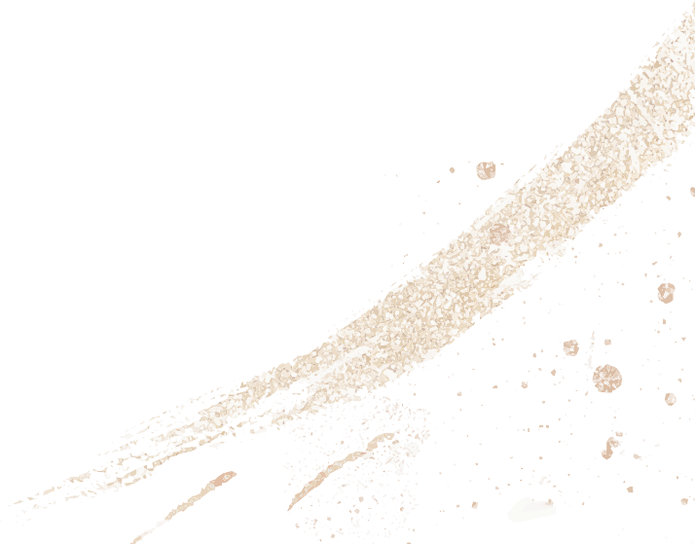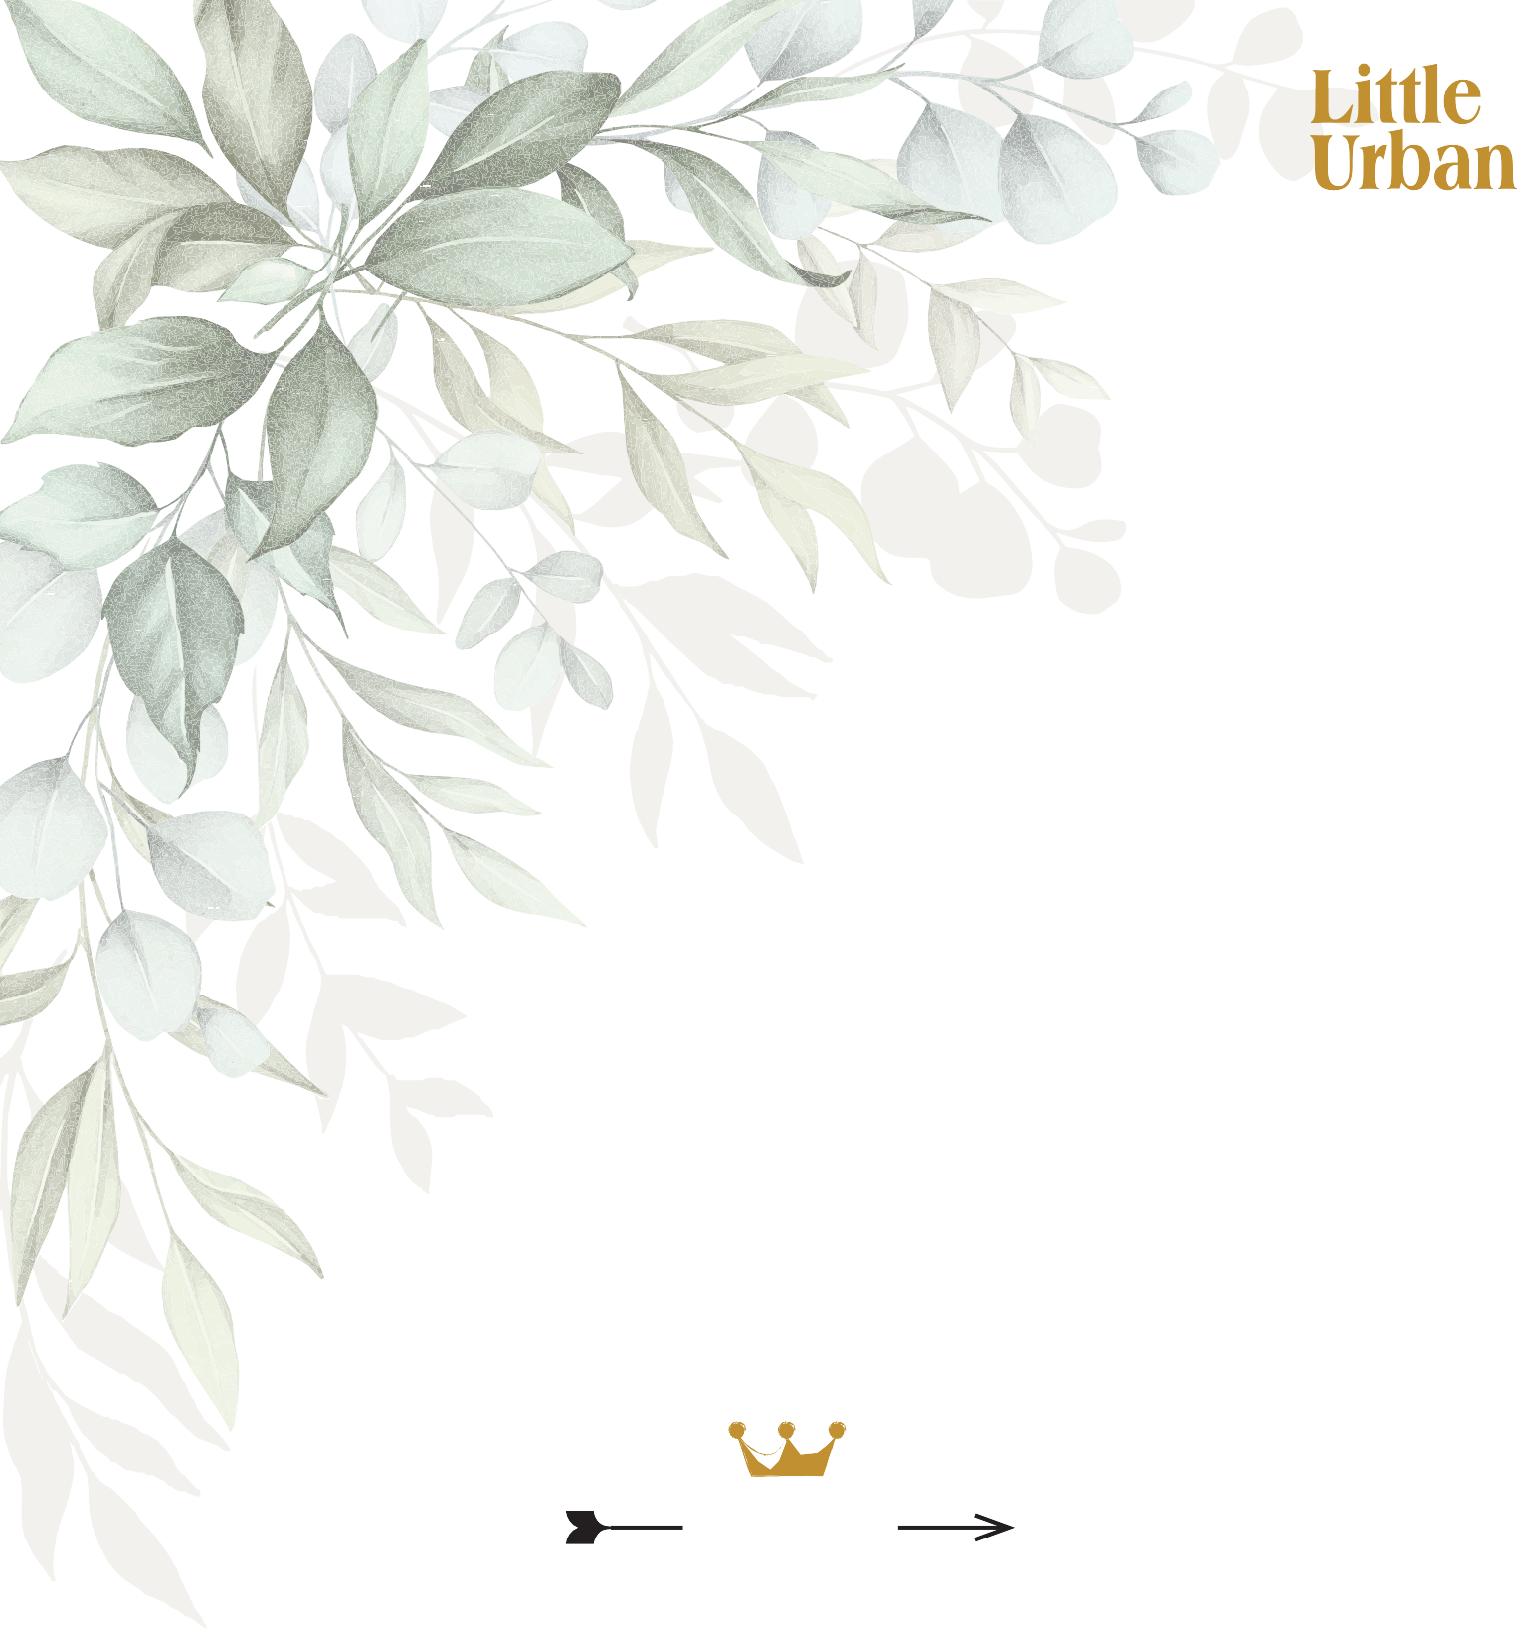M u

GLUTEN FREE HIGH TEA
High tea $42 per person or $50 with a glass of bubbles;
Vegan, vegetarian & Gulten free: $47 per person or $55 with a glass of bubbles; Children under 12 $25 for 5 items with a hot chocolate or juice.

Coronation Chicken Finger Sandwich Egg & Herb Finger Sandwich
Prawn Rice Paper Roll
Potato rosti, Avocado Mousse & Smoked Salmon Gluten Free Scone, Raspberry Jam & Cream Macaron
Mini Brownie
Orange Poppyseed Cake with Mascarpone Mini Gluten Free Passionfruit & Lemon Tart

1700s
Monday to Friday
11am to 2pm
Join us for High Tea, make a booking at Little Urban.

The British tradition of High Tea began in the mid- 1700s as an afternoon meal usually served between 3 and 4 pm.
Initially, it was a meal for the working class, taken standing up or sitting on tall stools, thus termed ‘high’.
Tea with cakes, scones and even cheese on toast were served.
This afternoon meal was adopted by society’s upper classes as an important event on the social calendar, rather than a meal for the working class.
For the ‘Leisure Classes’, High Tea served a practical purpose, allowing Ladies and Gentleman the opportunity of a substantial meal before attending the theatre or playing cards. Evening supper may not be served until fashionably late in the evening.
It was around this time that John Montagu, the Fourth Earl of Sandwich, came up with the idea of placing meat and other fillings between two slices of bread. This is how the High Tea sandwich was created.

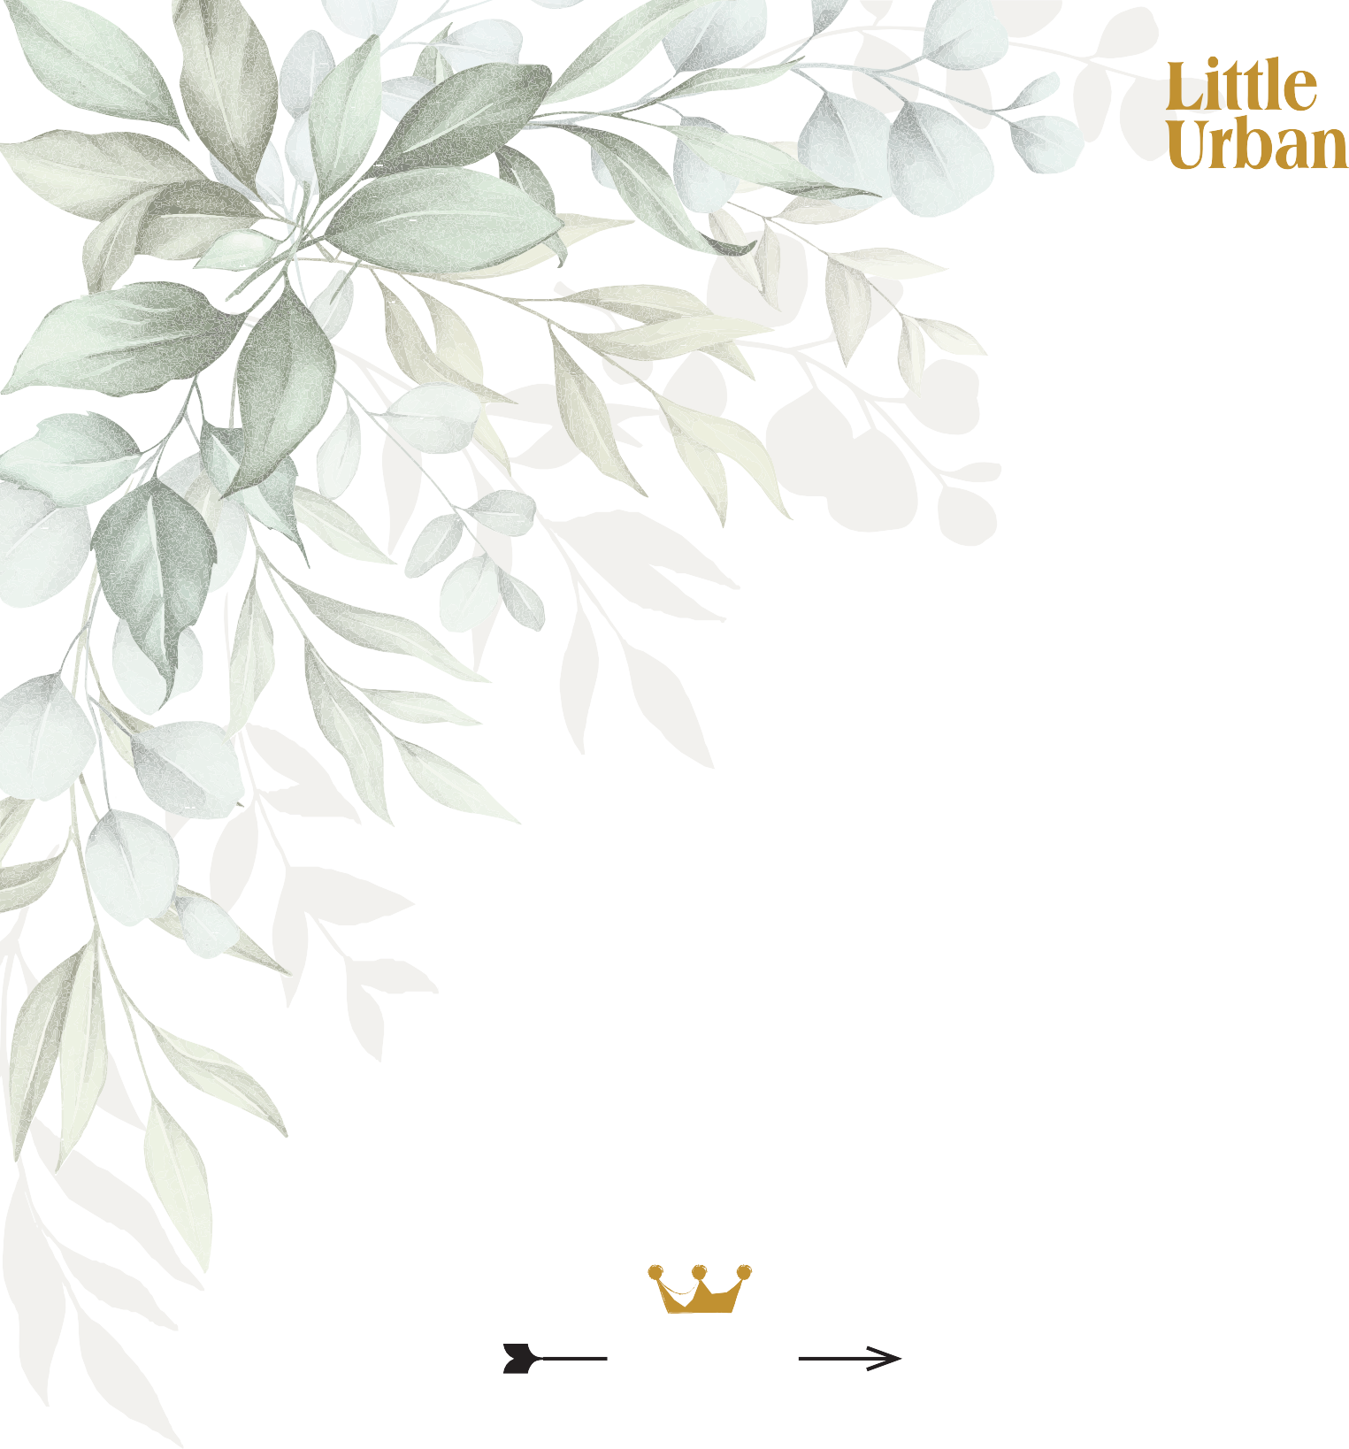M u

VEGAN HIGH TEA
High tea $42 per person or $50 with a glass of bubbles;
Vegan, vegetarian & Gulten free: $47 per person or $55 with a glass of bubbles; Children under 12 $25 for 5 items with a hot chocolate or juice.

Babaganoush on Potato Rosti Vegetable Rice Paper Roll
Hummus, Pickled Carrot & Capsicum Finger Sandwich Avocado Mousse, Tomato & Truffled Mushroom on Falafel Grilled Tofu & Sesame Seeds
Mini Seasonal Fruit Cup
Mini Chia Pot with Coconut Yoghurt Vegan Cheesecake
Bliss Ball

1700s
Monday to Friday
11am to 2pm
Join us for High Tea, make a booking at Little Urban.

The British tradition of High Tea began in the mid- 1700s as an afternoon meal usually served between 3 and 4 pm.
Initially, it was a meal for the working class, taken standing up or sitting on tall stools, thus termed ‘high’.
Tea with cakes, scones and even cheese on toast were served.
This afternoon meal was adopted by society’s upper classes as an important event on the social calendar, rather than a meal for the working class.
For the ‘Leisure Classes’, High Tea served a practical purpose, allowing Ladies and Gentleman the opportunity of a substantial meal before attending the theatre or playing cards. Evening supper may not be served until fashionably late in the evening.
It was around this time that John Montagu, the Fourth Earl of Sandwich, came up with the idea of placing meat and other fillings between two slices of bread. This is how the High Tea sandwich was created.

M u

VEGETARIAN HIGH TEA
High tea $42 per person or $50 with a glass of bubbles;
Vegan, vegetarian & Gulten free: $47 per person or $55 with a glass of bubbles; Children under 12 $25 for 5 items with a hot chocolate or juice.

Truffled Mushroom vol au vent Vegetable Rice Paper Roll
Egg & Herb Finger Sandwich Avocado & Tomato Croissant Scone, Raspberry Jam & Cream Macaron
Mini Passionfruit & Lemon Tart Orange & Poppyseed Cake with Mascarpone
Berry Cheesecake

1700s
Monday to Friday
11am to 2pm
Join us for High Tea, make a booking at Little Urban.

The British tradition of High Tea began in the mid- 1700s as an afternoon meal usually served between 3 and 4 pm.
Initially, it was a meal for the working class, taken standing up or sitting on tall stools, thus termed ‘high’.
Tea with cakes, scones and even cheese on toast were served.
This afternoon meal was adopted by society’s upper classes as an important event on the social calendar, rather than a meal for the working class.
For the ‘Leisure Classes’, High Tea served a practical purpose, allowing Ladies and Gentleman the opportunity of a substantial meal before attending the theatre or playing cards. Evening supper may not be served until fashionably late in the evening.
It was around this time that John Montagu, the Fourth Earl of Sandwich, came up with the idea of placing meat and other fillings between two slices of bread. This is how the High Tea sandwich was created.

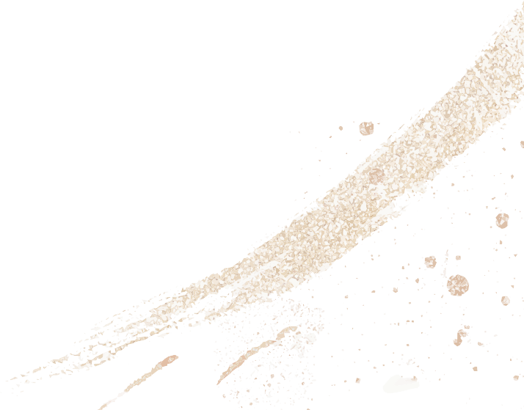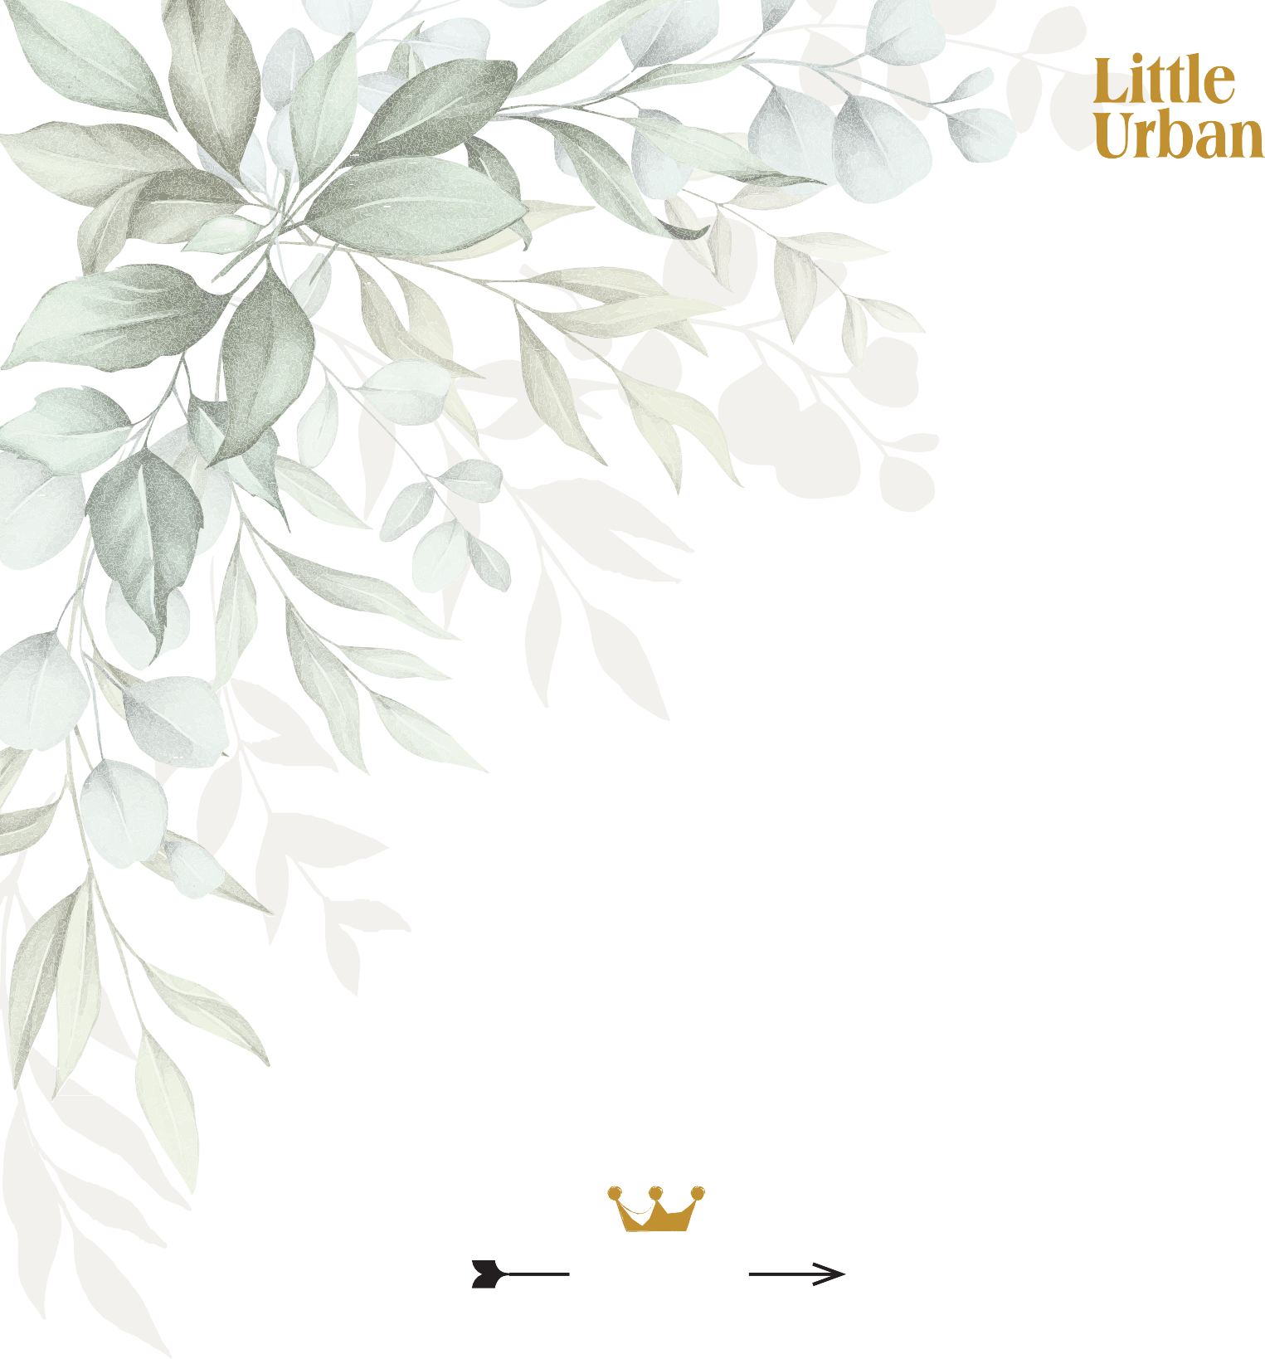M u

HARNEY & SON Leaf Tea Selection
Enjoy a tiered stand of scones, savouries, sandwiches & sweet treats served alongside premium Leaf teas.
- Earl Grey;
Black & white leafs with a hint of bergamot
- Ginger & Lemon;
Simple herbal blend, both spicy & sweet
- Goji Berry;
Zesty flavours, rosehip, hibiscus & fruit pieces
- Paris Blend;
Blended black teas, blackcurrant, caramel & vanilla
- Citron Green;
Orange flavours & sunflowers blended with Japanese Bancha
- English Breakfast;
Blend of black teas

1700s
Monday to Friday
11am to 2pm
Join us for High Tea, make a booking at Little Urban.

The British tradition of High Tea began in the mid- 1700s as an afternoon meal usually served between 3 and 4 pm.
Initially, it was a meal for the working class, taken standing up or sitting on tall stools, thus termed ‘high’.
Tea with cakes, scones and even cheese on toast were served.
This afternoon meal was adopted by society’s upper classes as an important event on the social calendar, rather than a meal for the working class.
For the ‘Leisure Classes’, High Tea served a practical purpose, allowing Ladies and Gentleman the opportunity of a substantial meal before attending the theatre or playing cards. Evening supper may not be served until fashionably late in the evening.
It was around this time that John Montagu, the Fourth Earl of Sandwich, came up with the idea of placing meat and other fillings between two slices of bread. This is how the High Tea sandwich was created.

